**SQLite Coding Proficiency Assessment – 1**

**Tasks:**

1. **Create Table and Insert Records:**
   * Create a table named products with the following columns:
     1. id (INT)
     2. name (TEXT)
     3. brand (TEXT)
     4. category (TEXT)
     5. price (REAL)
     6. stock (INT)
     7. discount (INT)
   * Insert the following records:

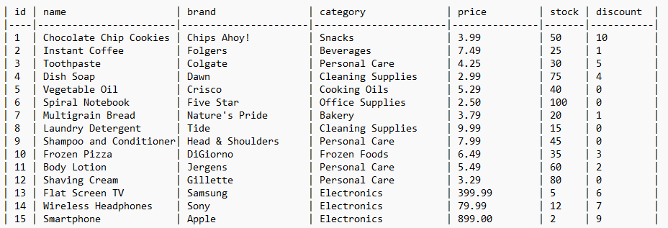

1. **Update Records:**
   * Update the discount of all products in the "Snacks" category to 10% if their current discount is less than 10%.
2. **Select Statements with Where Clauses:**
   * Write a query to retrieve all products currently on sale.
   * Write a query to retrieve all products from the "Beverages" category OR the "Personal Care" category that are not on sale.
   * Write a query to retrieve all products with a price between $5.00 and $15.00 (inclusive) and a stock level greater than 20.
   * Write a query to retrieve all products whose names contain the word "cream" (case-insensitive) and are not in the "Bakery" category.
3. **Order By, Group By, Having Clauses:**
   * Write a query to retrieve all products ordered by price (descending) and then by brand name (ascending).
   * Write a query to group products by category and display the average discount offered for each category.
   * Write a query to retrieve only those categories with an average discount greater than 5%.
4. **Limit and Offset:**
   * Write a query to retrieve the top 3 most expensive products from the products table.
   * Write a query to retrieve products starting from the 8th record onwards, limited to 5 results.
5. **Create Table from Select Query:**
   * Write a query to create a new table named low_stock_products containing only products with a stock level less than 10. The new table should have the same structure as the products table.
6. **Glob Condition:**
   * Write a query to retrieve all products whose names end with the characters "es" (case-insensitive).
7. **Subqueries:**
   * Write a query to retrieve all products that are more expensive than the average price of all products in the "Electronics" category.